Origins: Where Are the Aliens? **Overhead**



Exploring Spectra

Both of the following show the visible-light absorption spectrum for our sun. Notice that the second graph reveals more information—the amount of light absorbed is included.

**The Sun’s Spectrum**

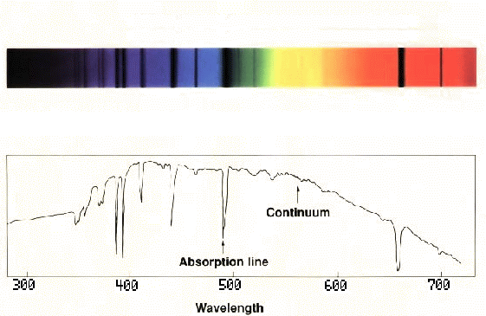

**Hydrogen**

**Absorption Lines**

**Hydrogen**

**Absorption Lines**

**Continuum**

**Absorption Line**

**Wavelength in nanometers**

ultraviolet wavelengths

**Intensity**

visible wavelengths

infrared wavelengths